|  |
| --- |
| ANNUAL REPORT  2024-2025 |

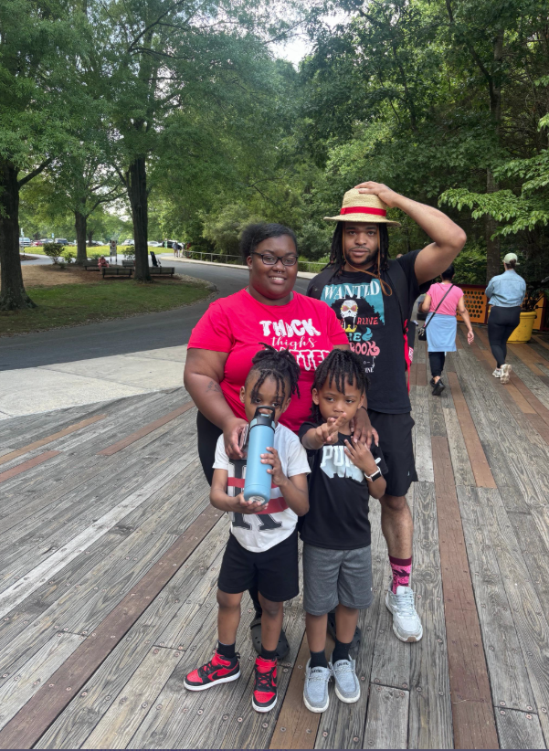**

Board of directors Approval: Policy Council Approval:

Tel: 434-793-5710

Address: 540 Holbrook Street

Danville, VA 24541

Email: [info@cicheadstart.org](mailto:info@cicheadstart.org)

Website: http://cicheadstart.org

Community Improvement Council, Inc.

**Administration**

## Program Design

Grant Name: Community Improvement Council, Inc.

Grant Number: 03CH011481

Agency Type: Private/Public Non-Profit (Non-CAA)

Center Type: Center-Based Option

Number of Total Classes: 9 (153 students)

## Program Information

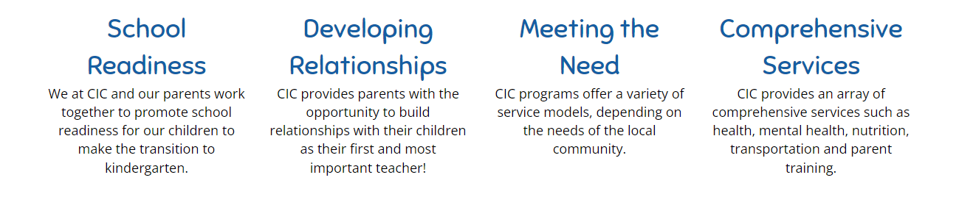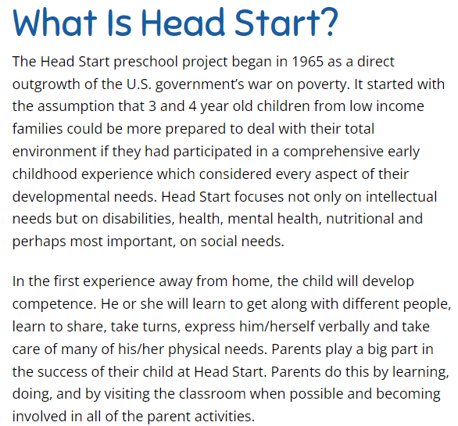

**Mission**

Community Improvement Council, Inc. – Head Start is to provide a flexible, comprehensive, quality service to income-eligible children and children with disabilities in their early stages of development and their families, through training and educational programs which will enhance their fullest potential for reaching future goals.

**Vision**

Through staff development, parental involvement, dedication, and collaboration with other agencies, the Community Improvement Council, Inc. will leave no income eligible child/family or child with a disability, unserved, in our community.

**Governance**

**Board of Directors**

The Board of Directors is the highest governing body of CIC, Inc. It is comprised of 11 community members and parents. In accordance with § 1301.3(c), Board advisory committees are established for effective governance including fiscal and legal expertise. The Board of Directors meetings are held quarterly.

**Tyrell Payne** *Board Chairperson / Community Representative*

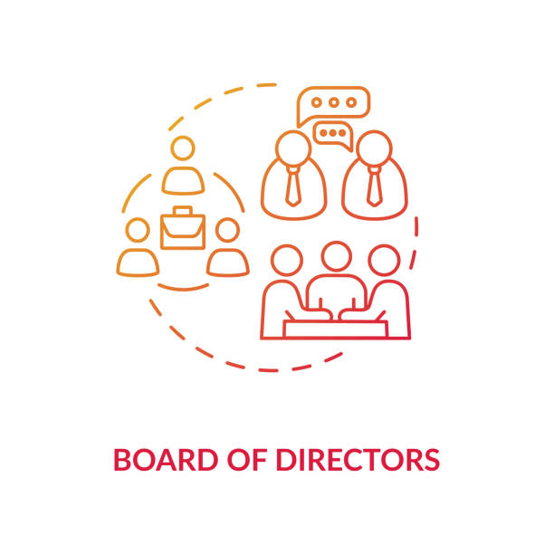**Jerry** **Williams** *Board Vice Chairperson / Legal Expert*

**Shelia** **Williamson-Branch** *Treasurer / Fiscal Expert*

**Patricia Daniel** *Secretary / Community Representative*

**Chasta White** *Policy Council Chair*

**Latoya Matthews** *Policy Council Representative*

**Shelby Irving** *Community Representative*

**Kasey** **Cunningham** *Community Representative*

**Janet** **Gwynn** *Community Representative*

**Marlo Burton** *Community Representative*

**Angela Wells** *Community Representative*

**Sylvester Townes** *Community Representative*

**Policy Council**

The Policy Council is a governing body of CIC, Inc. that provides oversight in the strategic direction of the organization. It is comprised of 14 parents and community representatives. The Policy Council meetings are held monthly.

**Chasta** **White** *Chairperson / Community Representative (Housing and Redevelopment)*

**Marlo** **Burton** *Vice Chairperson / Community Representative (PATHS) / Past Parent*

**Andrea** **Barley** *Secretary / Class 7 Representative*

**Jennifer Wingfield** *Vice Secretary / Class 8 Representative*

**Tyra Williamson** *Community Representative (Child Protective Services)*

**Lakiwii** **Milton-Babalola** *Community Representative (Danville Public Schools)*

**Aquina** **Adams** *Community Representative (Housing) / Past Parent*

**Latoria Jones** *Past Parent*

**Sherry Pritchett** *Past Parent*

**Ebony Malachi** *Class 1 Representative*

**Latoya** **Matthews** *Class 2 Representative*

**Jamillah Rasheed** *Class 3 Representative*

**Robin Batts** *Class 5 Representative*

**Porshe Taylor** *Class 9 Representative*

**Community** **Engagement**

**Community Collaboration**

CIC has partnered with various community organizations to promote a diverse educational experience for all participants and their families. Programs include, but are not limited to, visits from local law enforcement and first responders, Averett University’s Day-to-Engage, Week-to-Engage, Bonner Leaders, Growing Up Musically, DCC Teach, YMCA water safety courses, Owens Farm, Art Smart, Al’s Pals, Danville Art and Science Centers, PATHS, Bright Smiles, Center for Early Success, and Ready Regions.

**Special Projects/ Funding**

Specialized funding through local grants allot CIC, Inc. the opportunity to provide high quality services that are enjoyable and safe. Specialized funding and non-federal share donations afforded the organization the following: facility renovations, classroom supplies, field trips, health screenings, specialized educational opportunities, playground equipment, and so much more.

**Finance**

The program received Federal funds in the amount of $2,603,542 with an In-Kind match of $666,023 that was received through donations of time and services.

|  |  |  |
| --- | --- | --- |
| Expenditures | | |
| Personnel (Salaries) | 1.708,822 | 54% |
| Personnel (Fringe) | 230,718 | 7% |
| Supplies | 97,948 | 3% |
| Maintenance/Repairs | 130,261 | 4% |
| Training | 22,800 | 1% |
| Other | 956,316 | 31% |
| **Total** | 3,146,865 | 100% |

|  |  |  |
| --- | --- | --- |
| Source of Revenue | | Total % |
| Federal | 2,397,491 | 73% |
| In-Kind Contributions | 666,023 | 20% |
| USDA | 115,474 | 4% |
| Other/ Private Grants | 53,577 | 2% |
| CDBG | 37,000 | 1% |
| **Total** | 3,269,565 | 100% |

|  |  |
| --- | --- |
| 2024-2025 Proposed Budget | |
| Personnel | $1,652,397 |
| Fringe Benefits | $271,624 |
| Travel | $1,400 |
| Supplies | $39,500 |
| Contractual | $25,950 |
| Training & Technical Assist. | 22,800 |
| Other | $155,725 |
| **Total Proposed Funding** | $2,169,396 |

**With In-Kind match of $542,349.

**In-Kind Funding**

Community Foundation of the Dan River Region: $10,300

Womack Foundation: $7,644

J.T. Minnie Maude: $10, 839

**Total: $28, 783**

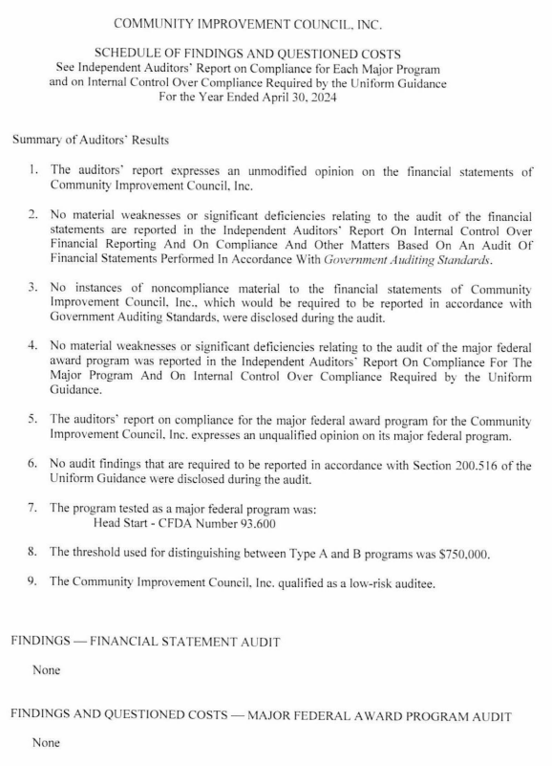**Audit**

**Monitoring/Review**

**Human Resources**

Total Cumulative Staff for 2024-2025: 50

Total Number of Terminated/Resigned Staff: 5

Total Number of Replaced positions: 5

*Total Number of Persons Providing Any Volunteer Services throughout the program year: 582*

|  |  |  |  |  |
| --- | --- | --- | --- | --- |
| Education by Service Area (Cumulative Staff) | | | | |
|  | High School Degree or Equivalent | Associates | Bachelor’s | Masters |
| Executive/Head Start Director | 0 | 0 | 1 | 0 |
| Finance/Human Resources | 0 | 0 | 1 | 1 |
| Office Manager/Program Monitor | 0 | 0 | 1 | 0 |
| Disability/Mental Health | 0 | 0 | 1 | 1 |
| Data/Compliance | 0 | 0 | 1 | 0 |
| Health/Safety | 0 | 0 | 1 | 0 |
| Family Service | 0 | 4 | 1 | 1 |
| Education | 1 (CDA Cert.) | 12 | 8 | 2 |
| Nutrition | 2 | 1 | 0 | 0 |
| Custodian | 1 | 0 | 0 | 0 |
| Transportation | 5 | 1 | 0 | 0 |
| Substitutes | 2 | 0 | 0 | 0 |



**FAMILY SERVICE & FAMILY ENGAGEMENT**

**Enrollment**

Funded Enrollment: 153

Cumulative Enrollment: 158

Turnover: 5

Age at time of enrollment:

3 Year Old: 80

4 Year Old: 78

Transitioning to Kindergarten: 77

Eligible for Re-entry: 76

**Family Events and Activities:**

Open House 138 Participating Families

Family Events 131 Participants

Families that Participated in

Parent/Child Activities 321 Volunteers

(current Head Start parents)

Hispanic ethnicity makes up 5% of the cumulative enrollment.

**Father Engagement**

CIC hosts a Fatherhood Committee that holds regular meetings

for all fathers and male figures in a child’s life. All fathers are

Also given the opportunity to complete family assessments and goal setting.

**Parent Involvement**

Family Assessments Completed: 137

Family Goal Setting: 137

**Parents’ Greatest Concerns Based on The Child’s Individual Development.**

The answers below are the most frequent answers to the questions about parents’ greatest concerns of their child’s development.

|  |  |
| --- | --- |
| 1. Following Everyday Routines | 6. Asking Questions and Attending to Answers |
| 1. Trying New Things | 7. Ability to Express Emotions |
| 1. Drawing Scribbles and Letters | 8. Interacting Well with Others |
| 1. Counting with Objects | 9. Hand-Eye Coordination |
| 1. Nutrition | 10. Fixing Broken Toys |

**Family Demographics:**

Total Number of Families: 147

Single Parent Families: 123

Two Parent Families: 24

Single Parent Family Demographics:

Mother: 108

Father: 22

Other: 4

Families Highest Level of Education

Less than a High School Degree: 19

High School Graduate or GED: 111

Associates Degree: 13

Bachelors or Advanced Degree: 4

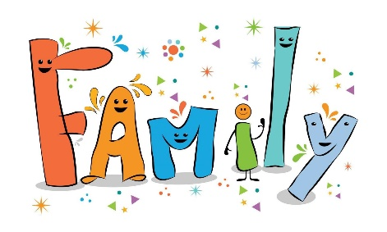

At End of Enrollment:

Total Number of Employed Families: 96

Total Number of Unemployed Families: 37

Total Number of Families listed as a Veteran: 1

Total Number of Families not in school or job training: 37

5.0 – Thriving, 4.0 – Self-Sufficient, 3.0 – Stable, 2.0 – Vulnerable, 1.0 - Crisis

**FOOD SERVICE**

CACRP Reimbursement

Estimated Number of Breakfast Served: 20,830

Estimated Number of Lunch Served: 20,772

Estimated Number of PM Snacks Served: 20,208

Nutritional and Wellness

Number of Students with Documented Allergies: 65

Food Allergies: 21

Seasonal Allergies: 40

Other Document Allergies: 9

**MENTAL HEALTH/DISABILITY**

**Mental Health**

Children Consulted for Mental Health Services: 10

Children Provided an Individual Mental Health Assessment: 8

Children Referred for Mental Health Services: 16

Children Received outside Mental Health Services: 2

Children Received an Individualized Service Plan within HS 13

**Disability**

Children with Approved Individual Education Program: 15

Disability services rendered by Danville Public Schools.

Children Received Special Education Related Services: 15

Children Eligible to Receive Special Needs Education

and Related Services Prior to Their Enrollment in Head Start: 3 (1 IEP, 2 IFSP)

Children Eligible to Receive Special Needs Education

and Related Services that were Determined Eligible after

their Enrollment in Head Start: 15

**HEALTH/SAFETY**

Vision

Total Administered: 158

Passed Initial Screening: 119

Required Referral: 11

Hearing

Total Administered: 158

Passed Initial Screening: 73

Required Referral: 1

Dental

Total Administered: 147

*All students are required to have an up-to-date medical physical and immunization record prior to entry.*

*For the program year, 2024-2025, 1 student was exempt from immunizations.*

**Health Insurance**

Receiving Medicaid and/or CHIP: 156

Private Health Insurance: 1

No Health Insurance: 2

**Transportation**

Students that Received Services: 106

Buses Owned by Program: 4

Buses Purchased this Program Year: 0

**EDUCATION**

**Brigance Head Start III (Developmental)**

Ongoing Assessment Tools:

Teaching Strategies Gold (Fall, Winter, Spring)

VKRP and Language & Literacy (Fall, Mid-Year. Spring)

CLASS

Assessments Administered: 99

Newly Enrolled Children: 99

Follow Up Assessment: 1

**Events (include but are not limited to):**

*Averett Day to Engage*

*Bowling*

*Week of the Young Child*

*Art Smart*

*Kite Day*

*Water Safety Classes*

*North Carolina Zoo*

*Head Start Carnival*

*Visit to Owen Farms*

**Educational Staff Development:** 42.5 hours required training

**Danville Public School Affiliation:** Disability Services & Kindergarten Registration

**Average Daily Attendance:** 86%



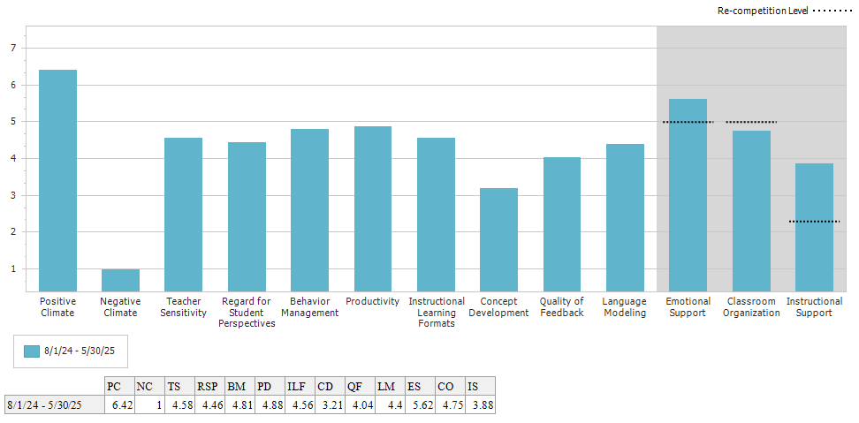

**Progress Towards Program Goals**

**Program Goal 1:** CIC Head Start will promote strong classroom communities by strengthening the social and emotional foundation of children, staff, and families.

* **Objective 1:** CIC will continue to implement the parent curriculum and classroom management/social-learning curriculum, Conscious Discipline and Positive Behavior Interventions and Support (PBIS).
  + Obtained training and materials needed to implement the curriculum at the start of the 24-25 SY.
  + Continued implementation of the Conscious Discipline Curriculum in 24-25 SY.
  + Renewed the curriculum for the 25-26 SY.
  + Offered parent classes and events centered around Conscious Discipline’s parent curriculum.
  + CIC has partnered with Conscious Discipline to become a Conscious Discipline School Family.
* **Objective 2:** CIC will enhance the knowledge, support, and resources for social emotional development for staff and families.
  + All staff attend annual training courses on Child Abuse & Neglect, Forbidden Actions & Mandated Reporting, and Trauma-Informed Care & Self-Care.
  + Education Staff had continued access to the Conscious Discipline video database throughout the year.
  + GOLD Social Emotional Percentages for Spring 2025:
    - Below Benchmark: 23%, Meets/Exceeds Benchmark: 77%
* **Objective 3:** CIC will use the CLASS tool to strengthen classroom communities.
  + CLASS data for Spring 2025:
    - Emotional Support: 5.62, Classroom Organization: 4.75, Classroom Support: 3.88
  + CIC partnered with The Center for Early Success to complete CLASS evaluations for all classrooms.
  + All 12 classrooms were coached in CLASS, focusing on Classroom Organization.

**Program Goal 2:** CIC Head Start will strengthen child outcomes to provide a solid academic foundation that promotes success for our students throughout their educational career.

* **Objective 1:** CIC will support and encourage regular attendance for all students to maximize the learning experiences for students.
  + Education and Family Services staff communicated to parents/guardians the importance of regular attendance (only if the child was feeling well) through calls, text, robo-calls, Class Dojo, material sent home.
    - A bike was gifted to the child with the best attendance for the school year.
  + Average Monthly Attendance Rate was 86% across 24-25 school year.
    - This is up 1% from the previous year’s average daily attendance.
  + CIC continued the implementation of Class Dojo to communicate with parents and children during the 24-25 school year and plan to continue its use into the 25-26 school year.
    - 99% of parents are connected on Class Dojo in 24-25. This is an increase of 14% from the previous year.
* **Objective 2:** CIC will enhance STEAM (Science, Technology, Engineering, Art, and Math) learning for students.
  + Obtained new STEAM materials for all classrooms. Professional Development at the beginning of the school year to demonstrate how to incorporate these new materials into the classroom.
  + GOLD “Science and Technology Percentages for Spring 2025:
    - Below Benchmark: 9%, Meets/Exceeds Benchmark: 91%
  + GOLD “The Arts” Percentages for Spring 2025:
    - Below Benchmark: 4%, Meets/Exceeds Benchmark: 96%
* **Objective 3:** CIC will enhance physical development for students.
  + GOLD “Physical” Percentages for Spring 2025: Below 28%, Meets/Exceeds: 72%
  + CIC acquired funding for new playground equipment to be installed.
  + Exercise study enhancement for Creative Curriculum.
  + Received classroom equipment; such as: balls, jump ropes, bowling, etc.

**Program Goal 3:** CIC Head Start will strengthen services for children and families transitioning into and out of Head Start to promote success for our students throughout their educational career.

* **Objective 1:** CIC will strengthen services to ensure families and children are prepared to enter the Head Start program.
  + Parent Committee participant survey data report: 100% of participants say that they had a clear understanding of the program and what to expect upon entry. 100% of participants said that the application process was lengthy and had more paper documents than they were anticipating.
  + Family Service Staff have switched to an entirely appointment based intake procedure to spend more one on one time with applicants to explain the entire process without interruptions.
* **Objective 2:** CIC will ensure all eligible students are enrolled in kindergarten.
  + With consent from parents, CIC sends a list of students transitioning into Kindergarten to the Danville Public Schools. The list contained the most recent form of contacts for those parents.
  + CIC will communicate with parents frequently regarding Kindergarten Registration with reminders leading up to the application deadline.
  + CIC sent home resources regarding Kindergarten Registration to the parents of students transitioning.
  + CIC hosted a DPS Kindergarten registration event to help families enroll their children into school.
  + CIC has the link to DPS Kindergarten Registration posted on our website under Parent Resources.
* **Objective 3**: CIC will ensure students receiving mental health services have a seamless transition into their elementary schools.
  + New MOU was established with DPS.
  + Upon parent approval, CIC, DPS, and Madeline Center (Mental Health Provider) will meet to discuss student progress, strengths, and weaknesses.
* **Objective 4:** CIC will ensure children and families are prepared for transition into Kindergarten.
  + CIC will contact parents and families regarding Kindergarten registration through robo-call reminders, text alerts through Child Plus and Class Dojo, as well as newsletters to eligible children as well as informing parents of DPS’s new online application system.
  + Parents will receive individual follow up information encouraging the families to register for Kindergarten.

**Program Goal 4:** CIC will support families in achieving goals to acquire a better quality of life beyond basic needs.

* **Objective 1**: CIC will support families in obtaining desired educational goals.
  + Our Parent Committee participant survey suggested phlebotomy classes and English as a 2nd language classes.
  + Have a Parent Board that lists all parents (with consent) who complete goals.
  + Family Services work with and offer support to all parents in achieving their goals.
* **Objective 2:** CIC will support families in obtaining desired employment goals.
  + Our Parent Committee suggested keyboarding classes.
  + CIC is partnering with Danville Community College and Adult Carrer and Education Center to promote higher education and offer free courses for families.
* **Objective 3:** CIC will assist families in increasing family well-being.
  + Our Parent Committee suggested the following would help with family well-being: counseling classes, credit building, anger management, alcohol and drug abuse mentoring, mental health resources (PTSD, trauma, anxiety, depression), Domestic Violence, elder abuse, self-defense, and human trafficking.

**Community Assessment Summary**

1. City Demographics
   * The community experienced a -.09% population decrease from 2021 to 2022.
   * There was a 0.2% increase in the Hispanic population of the community from 2021 to 2022.
   * The population of children under 5 has decreased by 85 children from 2021 to 2022.
   * 3.7% (+0.3%) of Danville residents were foreign born persons.
   * 9.2% (+2%) of Danville residents are veterans.
   * Rent increased from $688 to $733 from the previous reported year.
   * The number of families living in the same house for more than 1 year increased 0.6%.
   * Access to technology at home increased from 83.4% to 84.8%, a +1.4% change.
   * Civil labor force of able-bodied individuals 16+ years old decreased 0.5%.
   * Children in poverty increased 0.4%. All persons in poverty increased 2.1%
   * The City of Danville is recorded as paying nearly $20/hour less than the Virginia state average.
   * The following cost of living factors have decreased: housing (0.5%), groceries (0.5%), transportation (0.3%), and health care (3.6%). The following cost of living factors have increased: utilities (0.1%), and miscellaneous (6.8%)
2. Health and Social Services
   * The air quality in Danville has improved 2.9 points.
   * Cancer and Heart Disease remain the number two leading causes of death in the community.
   * Lead beat out Salmonellosis in communicable diseases for the #1 spot.
3. Nutrition
   * SNAP participants increased by 1,298 from 2022 to 2023.
   * TANF participants decreased by 178 from 2022 to 2023.
   * Eligible Medicaid Clients increased by 1,701 from 2022 to 2023.

We thank the families, children, staff, and community for their on-going love and support for the Head Start Program.